K V SHALIMAR BAGH
PRIMARY WING 2nd SHIFT
HOLIDAY ASSIGNMENT (SUMMER VACATION) 2020-21
CLASS V
Dear Students,

We are facing tough time due to Corona Virus Pandemic (COVID 19). So in this time of crisis we all believe that our students have matured enough to play a promising role in society. You must help your parents, make them happy, be disciplined and take care of all elders and the young ones. School is important but so is your health. Take care of yourself and each other (from a safe distance of course). And, no matter what happens this year, be proud of yourself, your resilience, and your ability to adapt to extreme circumstances. We are proud of each and every one of you. We hope you are all safe and healthy. We miss each and every one of you.

You all bring us more joy and happiness than any of you can imagine, and we hope we are together again soon emerging strong after fighting this Pandemic together. We at KV Shalimar Bagh firmly believe that under no conditions learning should stop and therefore we are engaged with you all over social media trying to make learning fun over remote connectivity. We all have structured certain exciting learning assignments which you all will enjoy working on.

ENGLISH
1. Take reading practice daily. Read at least 1 lesson from your Text book.
2. Learn the spellings of all new words from lesson 1 to 10, and take dictation test every 3rd day. Learn to use these words in sentences of your own.
3). Read 2-3 story books of your choice. Learn to narrate the story in your own words.
4)Write and learn any 5 poems of your TEXT BOOK.
5) Draw pictures (of your choice) from Ice-cream man, wonderful waste, Teamwork, Flying Together. (A4sheet if possible. )
6)Do one-page cursive handwriting regularly. (20 pages)
7) Write two self-created poems.
8)(a)Write 5 words with suffix: ly, ness, ful, ty, less b) Prefix: Re, Dis, Un,In, Im, ment
9)Write Short paragraph or 10 lines on following topics
a) My School
b) Myself
C) Visit to a mall
d)How I spent my summer vacation
e) My family
• Do all work in a separate notebook /rough notebook /loose pages : whatever available at home.

MATHEMATICS
Learn tables from 2 t0 20.

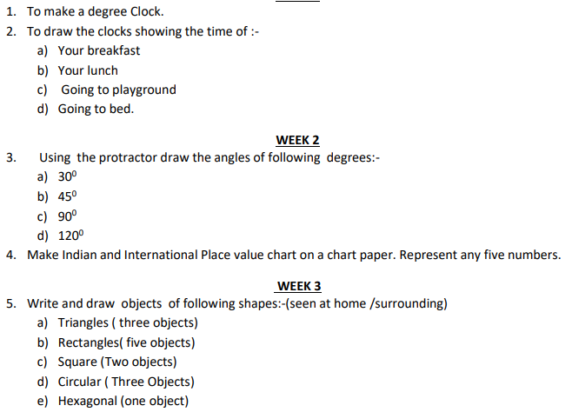

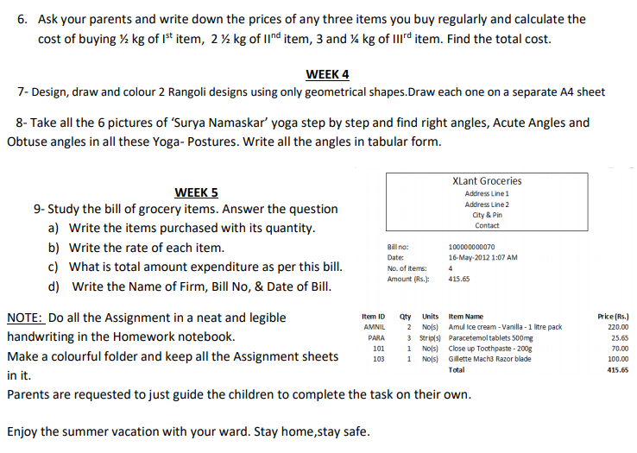
EVS
- Revise all the concepts of chapters 1 to 3.
- Draw your tongue on a A4 sheet and show areas of different kind of tastes on it.
- Make a model of our digestive system using waste material present at your home.
- Prepare a diet chart for the age group 9-12 years.
- Help your elders in household works to develop sense of responsibility.
- Make a puppet of any one animal using waste material .
- Do the following Aasnas daily for making your digestion system strong and for your good mental health : Pranayam,Kapalbhati, Anulom-Vilom,Bhramari .Make a video of any one day Aasan activity.
- Make a short video of any of your talent. (Drawing,painting,yoga,sports,dance,singing,mono acting etc.)
- Draw a poster on the topic ‘ Go Corona Go ‘.

HINDI
